Chapter 4 Mixtures
extra worksheet 2: Making salt
Science understanding Logical/mathematical Verbal/linguistic
Name: Class: Date:
All the salt produced in Australia is made by using sunlight to evaporate water from ponds of salt water. Seawater contains about 3.4% of total salts, of which 2.7% is sodium chloride. Sodium chloride is the salt that makes up almost all of the table salt you buy. The main constituents of seawater are shown in the table.
Component | Percentage (%)
sodium chloride | 2.68
magnesium sulfate | 0.22
calcium sulfate | 0.12
magnesium chloride | 0.32
potassium chloride | 0.07
other salts | 0.01
water | 96.58

The process
Salt water is pumped from the sea into a nearby field consisting of a series of shallow ponds. In the first pond, the action of the sun and the wind evaporates some of the water, making the water more concentrated in dissolved salts. The concentrated salt water is now called brine. As the concentration of the brine increases, so does its density. The density of the brine is measured regularly by scientists. Substances such as calcium carbonate crystallise and settle to the bottom of this first pond.
When the brine has reached a particular density it is pumped into the next pond. There it is left to evaporate further. As it evaporates, crystals of gypsum (calcium sulfate) form and settle to the bottom. The brine is then pumped into the next pond. Here the remaining water is allowed to evaporate for a long time. Sodium chloride crystals form and settle to the bottom of the pond. This is the salt that the producers want to sell. Once most of the sodium chloride has crystallised, the water is pumped out of this pond and discarded. More brine is pumped into the pond.
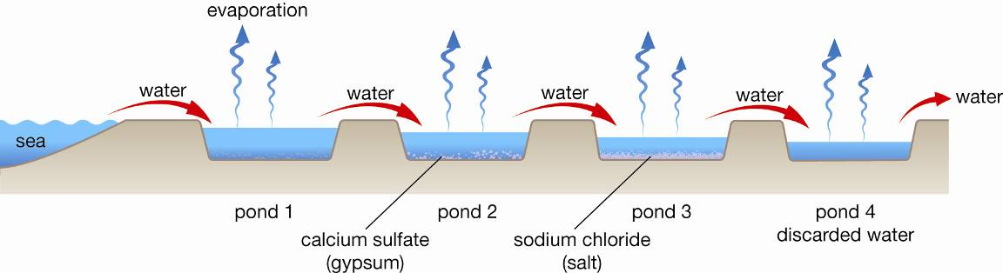
Salt is made by moving sea water through a series of ponds and letting the water evaporate
The layer of sodium chloride salt is normally harvested once a year. During harvest, the pond is drained and machines lift the layer of salt from the pond floor.
Excess brine is removed from the solid salt by a centrifuge. This spins the brine off, leaving the salt crystals damp but otherwise clean. The remaining moisture is driven off by heating to just above 110°C to produce dry salt crystals.
Crushing and sieving to specific size ranges are the final steps in producing the various salt grades. Sizes vary depending on the use, ranging from very coarse salt used for pickling and presentation of oysters in restaurant meals, right down to micro-fine salt used in making butter. In between there is a wide variety of particle sizes that cater for all needs, from food ingredients to pharmaceuticals, textiles, stockfeed and swimming pool additives.

Questions
1 Name the three most common salts in seawater.

2 Name the main ingredient in table salt.

3 Explain what happens to the seawater as evaporation of water steadily occurs in the first pond.

4 Seawater is 0.12 % calcium sulfate. This is less soluble than sodium chloride so it should crystallise before sodium chloride. Explain how the producers prevent this calcium sulfate ending up in the solid sodium chloride.

5 Explain how the scientists know when to pump the brine into the next tank.

6 Consider the table showing the constituents of seawater and propose why the scientists discard the remaining water once all the sodium chloride has crystallised.

7 Discuss two other methods of separation used in salt production besides crystallisation.

8 Discuss why salt is sorted into different crystal sizes by salt producers.

